Using Hardware Virtualization to Protect Commercial Software in Commodity Operating Systems

Abstract
Commodity operating systems are usually large and complex, and consequently, the software protection and the security it provided are often inadequate. As a result, commercial software and share software use various ways to protect themselves from piracy and data loss. To address the limitation, we introduce a virtual machine based framework called HBSP. In this framework, the protected application can communicate with the hypervisor and do any protection-related job in it, while the OS doesn’t have any references to the hypervisor. This allows the operating system to carry out the task of running the application, without knowing anything about the hypervisor. Thus, this framework can be used to protect a software effectively.
HBSP takes the advantage of memory –hiding, a mechanism that hides any piece of memory by unmap the guest virtual page number (GVPN) with the guest physical page number (GPPN). This mechanism offers an additional protection by restricting the access to a piece of memory, which can’t be discovered by scan address spaces.
We present the design and implementation of HBSP and give an example on how we can use such an approach to protect commercial software and share software from cracked by dynamic analysis. Our design has been fully implemented and used to protect applications running on an unmodified Windows XP system, the most popular commodity operating system, while imposing unnoticeable overhead for both I/O intensive workloads and CPU-intensive workloads when operating at 10 second intervals.

1. Introduction
Nowadays, commercial operating systems are deployed every corner in the home, office, and government, and it also needed to install various commercial software on them. Unfortunately, most of the operating systems can’t provide adequate security and software protection due to the design and hardware limitation. Consequently, nearly all the commercial software need to implement additional protection module.
First, hardware architecture protection is limited. Hardware architecture defines that the code running in the privileged mode has full access to the resources, While the code in the user mode can only access a limit range. So once the malicious code or analyzing tools is running in privileged mode, no more powerful mode can be used to stop it.
Second, there are always bugs and debugging functions in the commodity operating system. The kernel and the 3rd party device drivers of a commodity operating system contain millions of lines of code. And nearly all the commercial operating system provide functions to see other process’s address space and attach a thread to the other process for debug use. As a result, there is no way to stop someone who intended to crack a commercial software.
Finally, current platform can’t verify the sender of a message. When verify a serial key of software via Internet connections, the kernel can’t tell about one message comes from the remote machine or a malicious program. Even the remote machine can’t distinguish if a verification request comes from the application or not.
To improve the situation, previous efforts have explored
Unlike other approaches, when using HBSP constructed hypervisor to protect applications, there is no need to change the existing operating systems or to add additional hardware from them, there is even no change to the control flow between the application and the OS kernel. HBSP makes use of hardware virtualization technology to add another layer between privileged mode and OS. By using hypervisor, applications and existing host OS can be put in a virtual machine on the fly and continue running and vice versa when unloading the hypervisor. On one hand, the hypervisor using memory-hiding approach to hides itself in a memory region, On the other hand, it protects the software by handling hypercall. Consequently, the hypervisor runs transparently under the commercial operating system and holding important information about the application.
The following section presents the design goals of HBSP framework. In section 3, we will explain the framework implementation and the challenges when introducing in memory-hiding. Section 4 describes an example to protect a software by verifying itself with the help of HBSP framework in detail, as well as how it can prevent cracking by dynamic analysis. Section 5 shows how we apply our implementation to a default installation of the Windows XP and evaluates the overall performance. Section 6 reviews related work. Future work is discussed in section 7. Finally we will conclude the ideas in section 8.

2. Design Goals
We realized that we could dig deeper with the help of Hardware Enabled Virtualization (HEV) Technology. Consequently, we built this HBSP framework offering another line of software protection even on an untrusted environment. We will talk about its features first, and then the limitations we have not studied yet.

2.1 Features
HBSP framework is tailored from BluePill Project, We remove the anti anti-VMM detection and migrate it onto the x86 platform. As a result, we build a framework to protect software with the following advantages:

Install/Uninstall on the fly. Previous approach on protecting software divides the space into safe zone and unsafe zone. Thus it requires modifying the OS and even the boot sequence. Some other approaches also require the change on how software is packaged and used. By install/uninstalling hypervisor on the fly, It doesn’t affect any bit of the legacy OS, as well as the user experience.

Flexible Configuration. In order to support various ways to protect software, for example, to use Hardware-Virtual-Machine (HVM) protecting the application data and OS kernel, HBSP framework supply a rich set of low level interfaces to configure VMCS structure and memory strategy. While in the high level it also offers interfaces to initialize/start/shutdown the hypervisor. However, it’s not advised to keep all sensitive data or code in hypervisor for performance reasons.

Support for Other HEV technology. Currently HBSP framework supports Intel VT technology. Despite of this, there is also AMD SVM technology which is also largely adopted in the market. To minimize the cost when refactoring the hypervisor to support both platforms, we build a layer to hide the hardware difference. Thus, extending hypervisor platform support doesn’t affect other parts, as well as the protected software.

2.2 Limitations
As a hypervisor framework, HBSP can be used to implement software protection logic, but provide no availability in the face of anti-VMM detector by default. Thus a hypervisor is possible to be detected in a hostile environment, for example, it requires hundreds of times of cycles to handle an instruction trap in hypervisor than executing the instruction in guest machine. Also, the TLB cache is polluted when running the trap handler routines. And a malicious kernel can still record an application’s memory access patterns, thus the hypervisor can be tracked.
Second, though HBSP framework can be configured to use memory-hiding technology to hide itself under guest OS, its security is ultimately decided by the 3rd party hypervisor implementation and the software it going to protect. Bugs or security weakness could allow a malicious kernel or software steal any sensitive data from application. Despite of this, memory-hiding technology doesn’t protect against a DumpPhysicalMemory command.
Third, we make no attempt to let the memory-hiding technology support PAE mode, though it’s a desirable function and not so hard to implement. We have not tried to support this in the current system.
Finally, HBSP framework is designed to support only 1 guest machine at the moment, though a typical hypervisor can support more virtual machines as a nature. Regardless, HBSP framework offers a new approach in security, it brings in a valuable layer of protection, and requires no change to the hardware and the operating system.

3. Framework Implementation
Realizing the HBSP Framework design goal running on unmodified commodity operating systems has proved challenging. In this section we firstly introduce the control flow of HBSP Framework and how it controls the guest OS, then describe the HBSP framework architecture and the execution flow. Later we explain how it adopts the memory-hiding technology. In addition, we talk about the anti-debugging mechanism to enhance memory-hiding.

3.1 HBSP Framework Control Flow
Since HBSP Framework is built on HEV technology, its behavior is much like a guest machine controller on the top of the physical hardware. Consider a single guest machine running on the top layer. At any point of time, the whole system can be only in 1 context from the following three: guest application (Ring 3), guest kernel (Ring 0/1) and hypervisor (VMM). Both hypervisor interested events and ones should not be handled in the guest machine will transfer control to hypervisor. And hypervisor transfer control back to the guest machine explicitly after it finish handling the events.
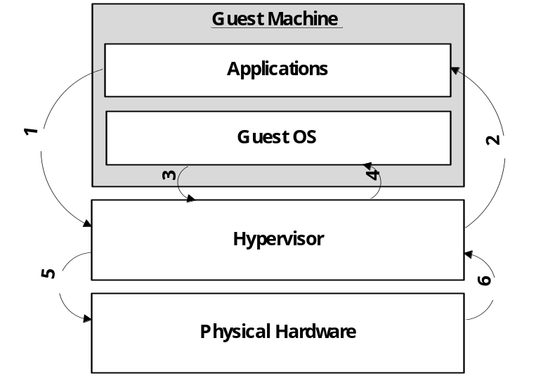
Figure 1. Basic State Transition Diagram
Figure 1 presents the basic state transition diagram. Both guest user mode instructions and guest kernel mode instructions could cause a #VMEXIT event to trap into the hypervisor. When guest applications execute a CPUID instruction, a hardware #VMEXIT event is generated and hardware informs hypervisor to start handling the event (Transition 1). The hypervisor examines the #VMEXIT reasons as well as the guest machine state which is stored automatically to determine how to handle it properly, hardware further uses them to resume the guest machine’s execution and transfer the control back to the guest machine (Transition 2).
Guest kernel has more chance to trap into the hypervisor, for example, a guest machine always causes #VMEXIT event at the moment reading MSR registers when the hypervisor configured monitoring RDMSR instructions with the help of HBSP Framework. Then the hypervisor does the same handling process as that with application (Transition 3, 4).
Some traps caused by requiring guest machine interact with physical hardware, for example, I/O related instructions. In HBSP Framework, a hypervisor also can be configured to intercept such operations. A Hypervisor mediates between guest machine and physical hardware in such condition, performing any additional operations on the results (Transition 5, 6), then returning control to the guest kernel or guest applications. With this approach, a hypervisor can cheat a malicious kernel and software to protect applications.

3.2 HBSP Framework Architecture
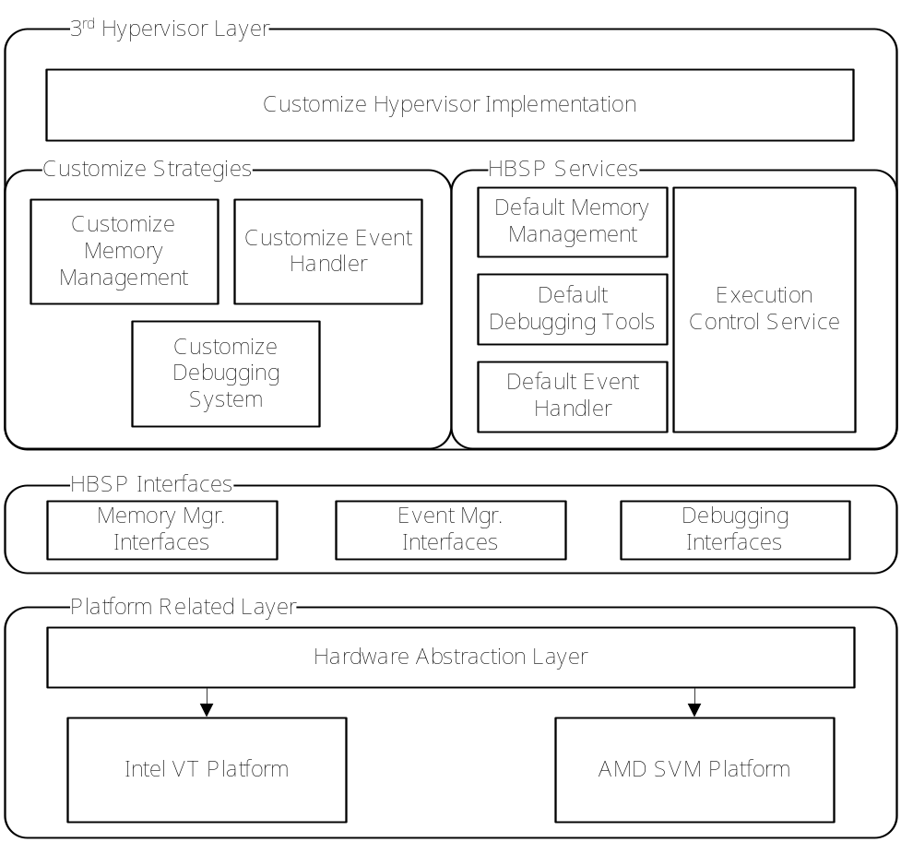

Figure 2. HBSP Framework Architecture. HBSP Framework consists of 3 Layers. User defined hypervisor will be constructed on the top layer, with the help of the HBSP Services and the HBSP Interfaces.

HBSP Framework uses a layered structure, providing a low level abstraction of the HEV technology as well as a selected set of interfaces. HBSP leverages this mechanism to enable a hypervisor developer implementing customized strategy and logic to protect software.
Figure 2 provides the HBSP Framework architecture. It is divided into 3 layers: Platform Related Layer, HBSP Interfaces and 3rd Hypervisor Layer. In this section we describe all the layers and the challenges to implement it in detail. The way to make use of this framework will be explained in Section 4.

Platform Related Layer. All the platform related implementations are held in this layer. Intel VT and AMD SVM are the most common implementations of HEV technology on x86/x64 platform. But as there are differences between Intel VT and AMD SVM, e.g. the differences in HEV-related instructions, in checking platform and in controlling virtual-machine control structures, the Platform Related Layer is responsible for hide the differences and provide an abstraction of HEV-support to the upper layers.
In Hardware Abstraction Layer, HBSP Framework require any implementation of HEV technology support the following routines (as we mentioned earlier, HBSP Framework is tailored from BluePill Project, so we keep most of the procedure names):
ArchIsHvmImplemented() This procedure checks if a hardware platform supports HEV technology.
ArchInitialize() This procedure takes the response of initialize the hypervisor and guest machine, it can also enter the VMM mode if needed.
ArchVirtualize() This routine is responsible for start the guest machine. As a result, the original OS is put into the virtual machine and continue executing instructions with no sense.
ArchDispatchEvent() This routine

3.2 Memory-hiding Technology
3.2.1 PageTable and Address Translation
3.2.2内存隐藏机制
3.3 Anti-Debugging Mechanism
Hypervisor内部屏蔽所有调试中断和标志位
4. Protecting Software
5. Experiments and Results
I/O密集型的程序 1s，2s…10s的interval
CPU密集型的程序 1s，2s…10s的interval
或者 SPEC06/08的测试
6. Related Work
7. Future Work
8. Conclusion

实验部分：
比较几个软件（最好是像类似于Apach HTTP Server，并且有源代码可编译并且要在Windows下运行的，或者像SPEC系列？）在未加入保护和加入保护下

Invisible Things Lab. BluePill Project. http://www.bluepillproject.org/stuff/nbp-0.32-public.zip, March 2008.
R. Ta-Min, L. Litty, and D. Lie. Splitting Interfaces: Making Trust Between Applications and Operating Systems Configurable. In Proceedings of the Seventh Symposium on Operating Systems Design and Implementation, pages 279–292, November 2006.
T. Garfinkel, B. Pfaff, J. Chow, M. Rosenblum, and D. Boneh. Terra: A Virtual Machine-Based Platform for Trusted Computing. In Proceedings of the Nineteenth ACM Symposium on Operating Systems Principles, pages 193–206, October 2003.
Xiaoxin Chen, Tal Garfinkel, E. Christopher Lewis, Pratap Subrahmanyam, Carl A. Waldspurger, Dan Boneh, Jeffrey Dwoskin and Dan R.K. Ports: Overshadow: A Virtualization-Based Approach to Retrofitting Protection in Commodity Operating Systems. In ASPLOS’08, March 2008
Nick L. Petroni, Jr. and Michael Hicks: Automated Detection of Persistent Kernel Control-Flow Attacks. In CCS’07, October 2007
Invisible Things Lab: Is GameOver() Anyone?. In Black Hat USA 2007, May 2007

